Emergency Responder Radio System
Coverage Report Test Results

Date Prepared: | Oct 26, 2023
Test File: | ncb_20231026_142933
Test Location: | NCB Builders
5947 W 58th Ave.
Arvada Co, 80004
Technician: | Joshua Emerson
FCC#: | PG00074022

Building: NCB Builders
Result: Pass

Test Report Summary
Channel/ Ch Group | Freq (MHz) | Technology | Band | Result | Area Points  passed (%) | Critical Points passed (%)
NCB: 1, 2, 3, 4, 5, 6, 7, 8 | 851.31250  854.73750  856.08750  857.53750  858.18750  858.56250  859.06250  859.53750 | P25 | Arvada-NCB BUILDERS PS | Pass | 60/60 (100%) | 0/0 (0%)

Test Details
Number of Floors Tested: | 3 | Result Calculation: | By area per floor
Number of Areas Tested: | 60 | Area Pass Criteria: | 95%
Number of Critical Points Tested: | 0 | Critical Points Pass Criteria: | 99%
 |  | Apply Adjacent Area Rule: | No

Equipment Configuration
Vendor | Application | Device | Calibration Expires | Antenna info
PCTEL | SeeHawk Touch  rel 4.0.0.1 | SeeGull IBflex Device rel 3.9.5.0  SN: 082302033 | 4-11-2025

Threshold Settings
Measurement | DL Area Point | DL Critical Point | DL Use for grading | UL Area Point | UL Critical Point | UL Use for grading
P25 Power (RSSI) | -95.0 dBm | -95.0 dBm | Yes | -95.0 dBm | -95.0 dBm | Yes
P25 S/N (SINR) | 20.0 dB | 22.0 dB | Yes | 20.0 dB | 22.0 dB | Yes
P25 FBER | 2.0 % | 1.5 % | Yes | 2.0 % | 1.5 % | Yes
DAQ | 3.0 |  | Yes

Floors Result
Floor Plan | NCB
Floor 3 | Pass
Floor 2 | Pass
Ground Floor | Pass

Floor: Floor 3
Group: NCB Channels: 1, 2, 3, 4, 5, 6, 7, 8
Result: Pass

Freq (MHz) | Tech | Band | Ant Gain | Cable Loss | Ph. | Type | Mod | NAC | Area Points passed (%) | Critical Points passed (%)
851.31250  854.73750  856.08750  857.53750  858.18750  858.56250  859.06250  859.53750 | P25 | Arvada-NCB BUILDERS PS | 0.00 | 0.00 | _  _  _  _  _  _  _  1 | CC  CC  CC  CC  CC  CC  CC  CC | _____  _____  _____  _____  _____  _____  _____  CQPSK | ___  ___  ___  ___  ___  ___  ___  A | 20/20 (100%) | 0/0 (0%)

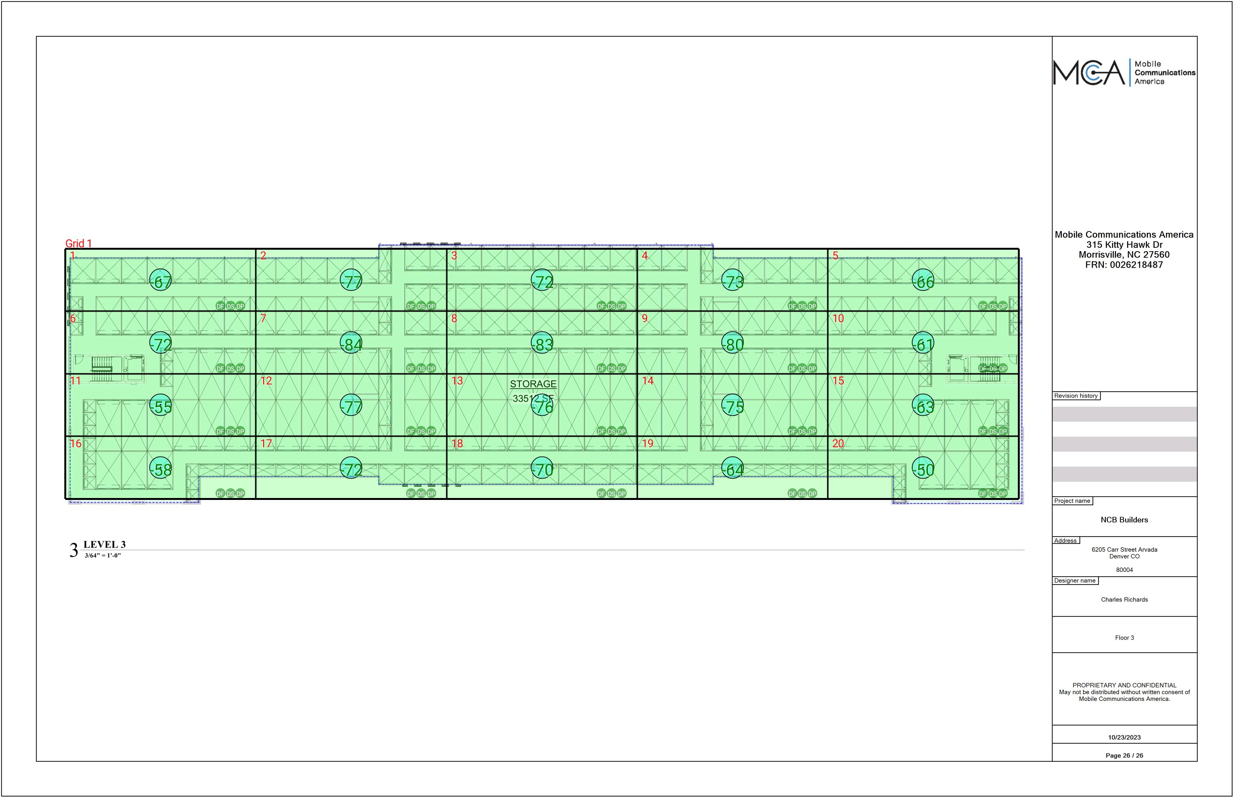

Grid | # of Areas | Area Size (sq. ft) | Area Width  (ft) | Area Height  (ft) | Ignore Area Color | Comments
1 | 20 | 1816.19 | 74.24 | 24.46 | Black

Floor: Floor 3
Group: NCB Channels: 1, 2, 3, 4, 5, 6, 7, 8

Area Points
Grid | Area | DL  Power  (dBm) | DL  S/N  (dB) | DL  FBER  (%) | DL  DAQ | UL  Power  (dBm) | UL  S/N  (dB) | UL  FBER  (%) | UL  DAQ | UL Tested | Result | DL  Loss  (dB) | Comment
1 | 1 | -66.74 | 35.42 | 0.00 |  |  |  |  |  |  | Pass
1 | 2 | -76.36 | 35.35 | 1.20 |  |  |  |  |  |  | Pass
1 | 3 | -71.95 | 35.70 | 0.00 |  |  |  |  |  |  | Pass
1 | 4 | -72.04 | 35.48 | 1.08 |  |  |  |  |  |  | Pass
1 | 5 | -65.72 | 35.31 | 0.00 |  |  |  |  |  |  | Pass
1 | 6 | -71.15 | 34.07 | 0.00 |  |  |  |  |  |  | Pass
1 | 7 | -83.42 | 35.22 | 0.00 |  |  |  |  |  |  | Pass
1 | 8 | -82.55 | 35.38 | 0.00 |  |  |  |  |  |  | Pass
1 | 9 | -79.68 | 35.73 | 0.00 |  |  |  |  |  |  | Pass |  | n 1
1 | 10 | -60.80 | 33.92 | 0.00 |  |  |  |  |  |  | Pass
1 | 11 | -54.87 | 33.36 | 0.00 |  |  |  |  |  |  | Pass
1 | 12 | -76.50 | 35.37 | 0.00 |  |  |  |  |  |  | Pass
1 | 13 | -75.39 | 36.42 | 0.00 |  |  |  |  |  |  | Pass
1 | 14 | -74.04 | 37.67 | 0.00 |  |  |  |  |  |  | Pass
1 | 15 | -62.01 | 37.68 | 0.00 |  |  |  |  |  |  | Pass
1 | 16 | -57.80 | 33.24 | 1.03 |  |  |  |  |  |  | Pass
1 | 17 | -71.88 | 36.65 | 0.00 |  |  |  |  |  |  | Pass
1 | 18 | -69.03 | 36.02 | 0.00 |  |  |  |  |  |  | Pass
1 | 19 | -63.75 | 37.84 | 0.00 |  |  |  |  |  |  | Pass
1 | 20 | -49.99 | 36.82 | 0.00 |  |  |  |  |  |  | Pass

Floor: Floor 2
Group: NCB Channels: 1, 2, 3, 4, 5, 6, 7, 8
Result: Pass

Freq (MHz) | Tech | Band | Ant Gain | Cable Loss | Ph. | Type | Mod | NAC | Area Points passed (%) | Critical Points passed (%)
851.31250  854.73750  856.08750  857.53750  858.18750  858.56250  859.06250  859.53750 | P25 | Arvada-NCB BUILDERS PS | 0.00 | 0.00 | _  _  _  _  _  _  _  1 | CC  CC  CC  CC  CC  CC  CC  CC | _____  _____  _____  _____  _____  _____  _____  CQPSK | ___  ___  ___  ___  ___  ___  ___  A | 20/20 (100%) | 0/0 (0%)

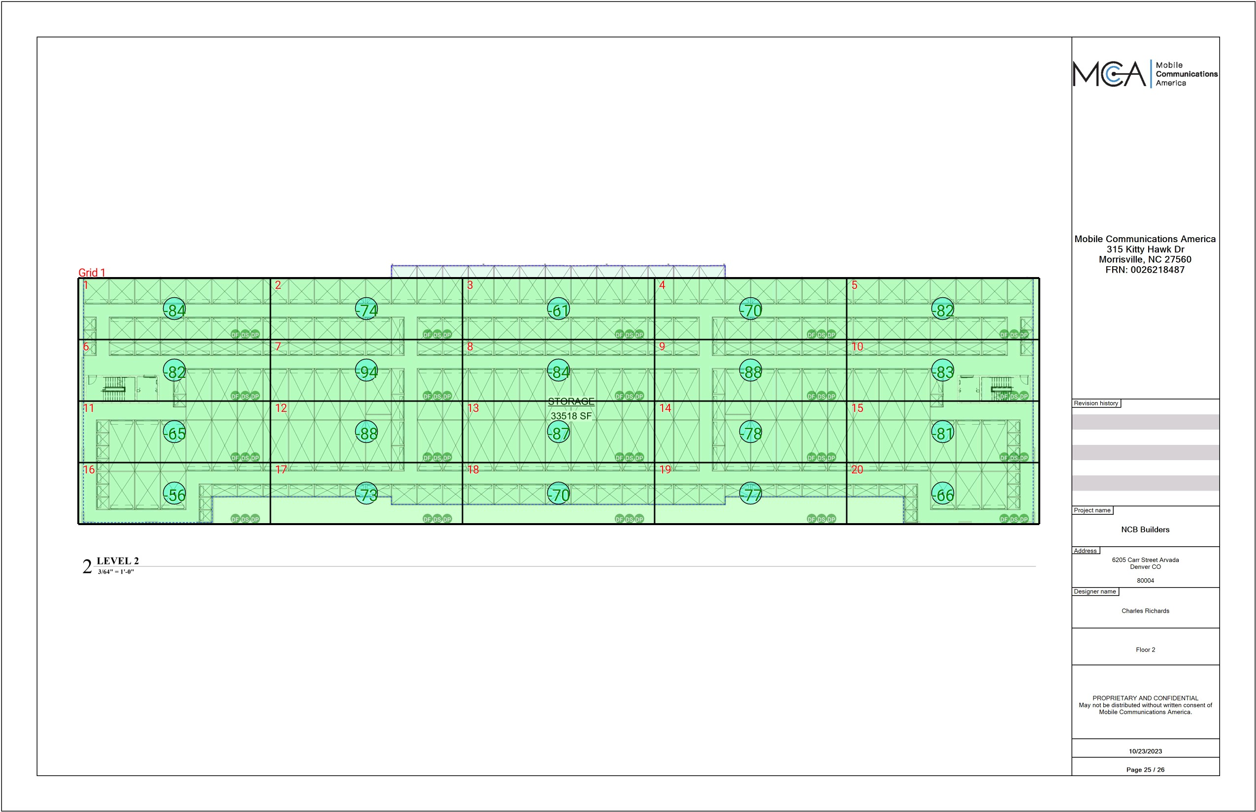

Grid | # of Areas | Area Size (sq. ft) | Area Width  (ft) | Area Height  (ft) | Ignore Area Color | Comments
1 | 20 | 1770.61 | 74.22 | 23.86 | Black

Floor: Floor 2
Group: NCB Channels: 1, 2, 3, 4, 5, 6, 7, 8

Area Points
Grid | Area | DL  Power  (dBm) | DL  S/N  (dB) | DL  FBER  (%) | DL  DAQ | UL  Power  (dBm) | UL  S/N  (dB) | UL  FBER  (%) | UL  DAQ | UL Tested | Result | DL  Loss  (dB) | Comment
1 | 1 | -83.77 | 36.84 | 0.00 |  |  |  |  |  |  | Pass
1 | 2 | -73.08 | 37.31 | 0.00 |  |  |  |  |  |  | Pass
1 | 3 | -60.78 | 37.62 | 0.00 |  |  |  |  |  |  | Pass
1 | 4 | -69.23 | 36.62 | 0.00 |  |  |  |  |  |  | Pass
1 | 5 | -81.57 | 36.66 | 0.00 |  |  |  |  |  |  | Pass
1 | 6 | -81.35 | 36.71 | 0.00 |  |  |  |  |  |  | Pass
1 | 7 | -93.65 | 33.55 | 0.00 |  |  |  |  |  |  | Pass
1 | 8 | -83.97 | 36.98 | 0.00 |  |  |  |  |  |  | Pass
1 | 9 | -87.46 | 34.54 | 0.00 |  |  |  |  |  |  | Pass
1 | 10 | -82.99 | 36.85 | 0.00 |  |  |  |  |  |  | Pass
1 | 11 | -64.41 | 37.25 | 0.00 |  |  |  |  |  |  | Pass
1 | 12 | -87.22 | 36.12 | 0.00 |  |  |  |  |  |  | Pass
1 | 13 | -86.59 | 35.67 | 0.00 |  |  |  |  |  |  | Pass
1 | 14 | -77.38 | 36.25 | 0.00 |  |  |  |  |  |  | Pass
1 | 15 | -80.28 | 36.60 | 0.00 |  |  |  |  |  |  | Pass
1 | 16 | -55.43 | 36.19 | 0.00 |  |  |  |  |  |  | Pass
1 | 17 | -73.00 | 37.22 | 0.00 |  |  |  |  |  |  | Pass
1 | 18 | -69.55 | 36.63 | 0.00 |  |  |  |  |  |  | Pass
1 | 19 | -76.22 | 36.37 | 0.00 |  |  |  |  |  |  | Pass
1 | 20 | -65.80 | 33.37 | 0.00 |  |  |  |  |  |  | Pass

Floor: Ground Floor
Group: NCB Channels: 1, 2, 3, 4, 5, 6, 7, 8
Result: Pass

Freq (MHz) | Tech | Band | Ant Gain | Cable Loss | Ph. | Type | Mod | NAC | Area Points passed (%) | Critical Points passed (%)
851.31250  854.73750  856.08750  857.53750  858.18750  858.56250  859.06250  859.53750 | P25 | Arvada-NCB BUILDERS PS | 0.00 | 0.00 | _  _  _  _  _  _  _  1 | CC  CC  CC  CC  CC  CC  CC  CC | _____  _____  _____  _____  _____  _____  _____  CQPSK | ___  ___  ___  ___  ___  ___  ___  A | 20/20 (100%) | 0/0 (0%)

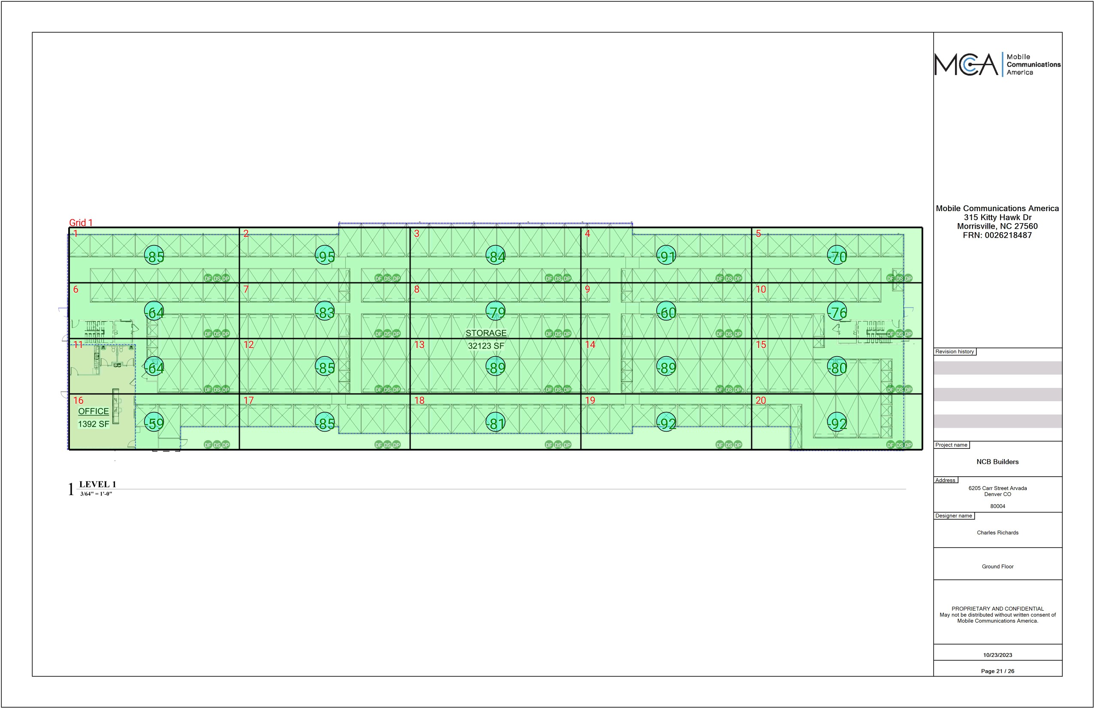

Grid | # of Areas | Area Size (sq. ft) | Area Width  (ft) | Area Height  (ft) | Ignore Area Color | Comments
1 | 20 | 1781.31 | 73.85 | 24.12 | Black

Floor: Ground Floor
Group: NCB Channels: 1, 2, 3, 4, 5, 6, 7, 8

Area Points
Grid | Area | DL  Power  (dBm) | DL  S/N  (dB) | DL  FBER  (%) | DL  DAQ | UL  Power  (dBm) | UL  S/N  (dB) | UL  FBER  (%) | UL  DAQ | UL Tested | Result | DL  Loss  (dB) | Comment
1 | 1 | -84.40 | 35.95 | 0.00 |  |  |  |  |  |  | Pass
1 | 2 | -94.84 | 37.27 | 0.00 |  |  |  |  |  |  | Pass
1 | 3 | -83.70 | 36.37 | 0.00 |  |  |  |  |  |  | Pass |  | '
1 | 4 | -90.85 | 36.43 | 0.00 |  |  |  |  |  |  | Pass
1 | 5 | -69.01 | 36.09 | 0.00 |  |  |  |  |  |  | Pass
1 | 6 | -63.38 | 36.52 | 0.00 |  |  |  |  |  |  | Pass
1 | 7 | -82.57 | 36.00 | 0.00 |  |  |  |  |  |  | Pass
1 | 8 | -78.89 | 36.57 | 0.00 |  |  |  |  |  |  | Pass
1 | 9 | -59.96 | 37.68 | 0.00 |  |  |  |  |  |  | Pass
1 | 10 | -75.99 | 37.30 | 0.00 |  |  |  |  |  |  | Pass
1 | 11 | -63.14 | 37.32 | 0.00 |  |  |  |  |  |  | Pass
1 | 12 | -84.32 | 27.80 | 0.00 |  |  |  |  |  |  | Pass
1 | 13 | -88.82 | 35.56 | 0.00 |  |  |  |  |  |  | Pass
1 | 14 | -88.79 | 35.58 | 0.00 |  |  |  |  |  |  | Pass
1 | 15 | -79.98 | 36.91 | 0.00 |  |  |  |  |  |  | Pass
1 | 16 | -58.49 | 36.95 | 0.00 |  |  |  |  |  |  | Pass
1 | 17 | -84.18 | 35.69 | 0.00 |  |  |  |  |  |  | Pass
1 | 18 | -80.25 | 36.86 | 0.00 |  |  |  |  |  |  | Pass
1 | 19 | -91.68 | 34.55 | 0.00 |  |  |  |  |  |  | Pass
1 | 20 | -91.86 | 36.00 | 0.00 |  |  |  |  |  |  | Pass

Additional Info

